PYTHON TOOLKIT : TICKET CLUSTERING ANALYSIS
DESIGN DOCUMENT

1. Introduction & Objectives
This system automates the generation of detailed ticket summaries and categorizes tickets into meaningful clusters. It addresses the challenge of unstructured, inconsistent, and noisy ticket descriptions by providing:
- Generated Summary (~200 words) derived exclusively from Short Description , Description, Additional Comments and Work Notes.
- Ticket Cluster assignment into predefined categories or new clusters if required.
- Structured outputs in Excel/CSV for downstream reporting and integration with ticketing tools.
Objective: Improve ticket triage, routing efficiency, and analytics by enabling automated summarization and clustering.

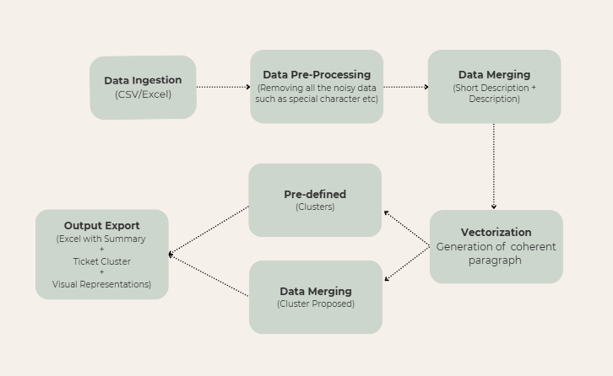

2. Data Understanding
The system works with ticket data containing columns such as:
- Number – Ticket identifier
- Account – Customer/tenant raising the ticket
- Short Description – Concise one-line problem statement
- Category – Initial user-provided category
- Priority – Criticality/urgency
- Description – Detailed issue explanation
- Assigned To, Additional Comments, Work Notes, Resolution Notes – Contextual/auxiliary fields
Important: Only Short Description, Description, Additional Comments and Work Notes are used for generating summaries and clustering.
3. Preprocessing Logic
- Data loading: Input CSV/Excel is read, ensuring correct schema.
- Cleaning: Handles whitespace, newline normalization, special characters, and duplicates.
- Filtering: Retains only Short Description and Description for NLP processing.
- Missing handling: If Description is absent, fallback to Short Description only.
- Metadata creation: Tracks ticket lengths, presence of fields, and preprocessing outcomes.
This ensures high-quality, normalized inputs before passing to NLP models.
4. NLP Approach
The system employs LLM-based summarization and vectorization:
- Summarization:
  - Uses an LLM to combine Short Description and Description into a coherent, structured summary (~200 words).
  - Style is professional and concise, avoiding fabricated details.
  - Summaries maintain factual integrity and represent the original issue clearly.
- Vectorization (in vectorize.py):
  - Converts text into embeddings (dense vector representations).
  - Enables semantic similarity comparisons and clustering.
  - Provides foundation for grouping related tickets.
5. Clustering Approach
- Rule-based classification:
  - Predefined clusters like ServiceNow login issues, Performance issues, etc.
  - Keyword and phrase matching for high-confidence assignments.
- Semantic clustering:
  - Embeddings from vectorize.py are clustered using algorithms like K-Means or HDBSCAN.
  - Similar tickets are grouped even if worded differently.
- Cluster naming:
  - Extracts key terms or uses LLMs to propose meaningful cluster labels.
  - Matches new clusters against predefined categories; otherwise, proposes new categories.
6. Tech Stack
- Language: Python
- Data Handling: pandas, numpy
- Summarization: LLM APIs (e.g., OpenAI, HuggingFace models)
- Embeddings: sentence-transformers or managed embedding APIs
- Clustering: scikit-learn (KMeans), HDBSCAN for semantic grouping
- Configuration: YAML-based config management
- Outputs: Excel/CSV via pandas I/O functions

8. Evaluation & Output
Evaluation
- Summarization:
  - Human validation for fluency, factual correctness, and completeness.
  - Automatic checks for summary length and entity overlap with source.
- Clustering:
  - Internal metrics: silhouette score, cluster cohesion.
  - Business metrics: accuracy of routing, reduction in manual reassignments.
Output
- Final Excel/CSV contains all original columns plus:
  - Generated Summary
  - Ticket Cluster
  - Optional metadata like confidence score and assignment method

